Wednesday, 9 September 2026, postcard

Art, Simpson's in the Strand, and The Comedy About Spies

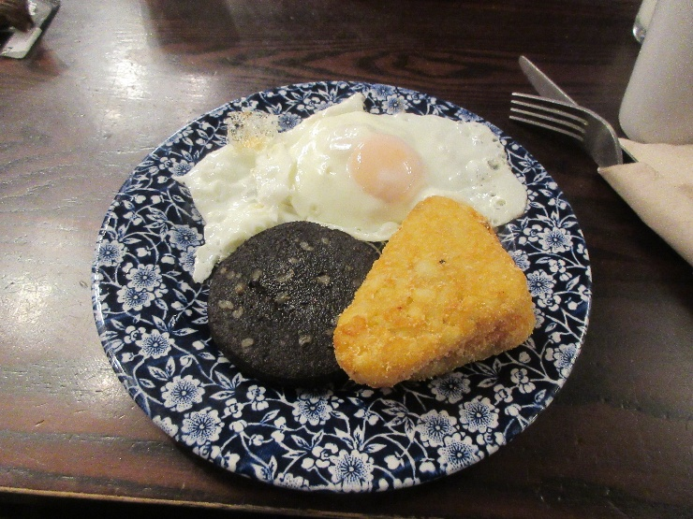
Last full day in London. This morning, I didn't bother with the QR code and just ordered breakfast at the bar. David repeated yesterday's choices, but I ordered strictly from the "breakfast extras" section—two fried eggs (they were back to being perfect), two hashbrowns, and a slice of black pudding. Just what I wanted.

Then we walked around the outside of the NPG to The National Gallery, where they have portraits, yes, but just scattered among all the other art.
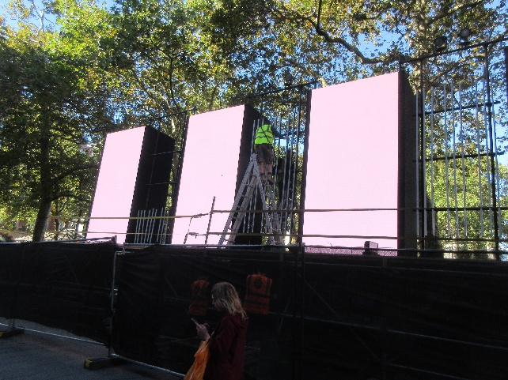
Along the way I got this shot of some of the eight huge LCD video screens that have gone up facing the Odeon.

As we strolled, we talked about where we wanted to start (knowing we wouldn't have time for the whole collection) and bemoaned that galleries never have rooms just devoted to still life, but we had other preferences to (Flemish old masters, impressionists, etc.). Imagine our surprise when just a few rooms into our visit, we encountered a room devoted to still life! In this case, all floral and entymological.
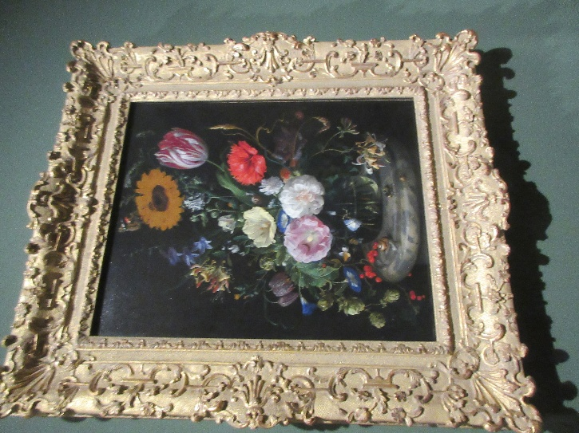
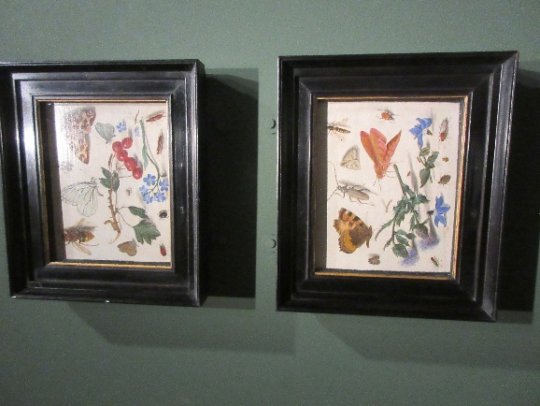
Here's an arrangement by Jan Davidsz, de Heem, the same guy, I'm pretty sure, who painted that big still life of fruit and animals that hangs in the Ringling in Sarasota and that we have a poster of on our dining-room wall.

And I loved this pair of little studies of insects (and a couple of plants) by Jan Van Kessel the Elder.
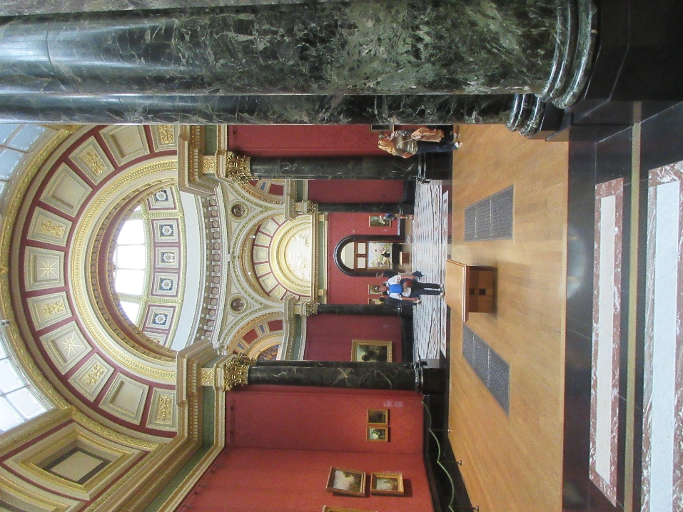
The museum itself is gorgeous, independent of the art hanging there.

We found the Vermeers, as well as a couple of rooms full of impressionists. David's comment was "I'm glad to see Manet getting his due; most places, it's Monet, Monet, Monet." (I admit, I'm a Monet fan, and he was well represented, too.)

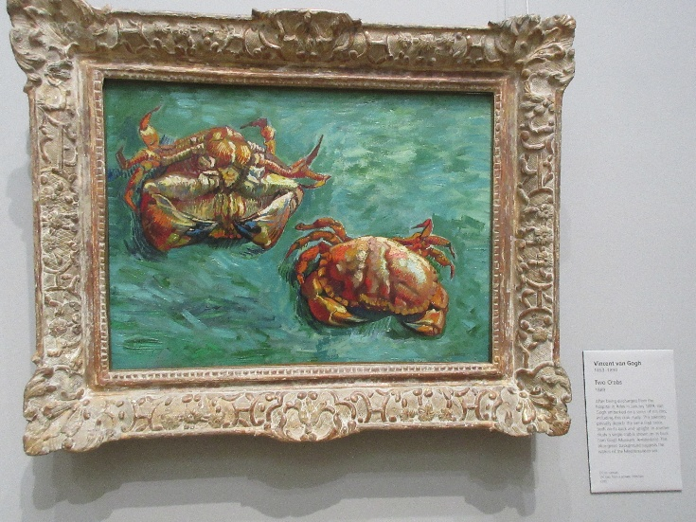
I'm not usually a fan of van Gogh, but some of his early work is great, They had this nice little study of crabs.

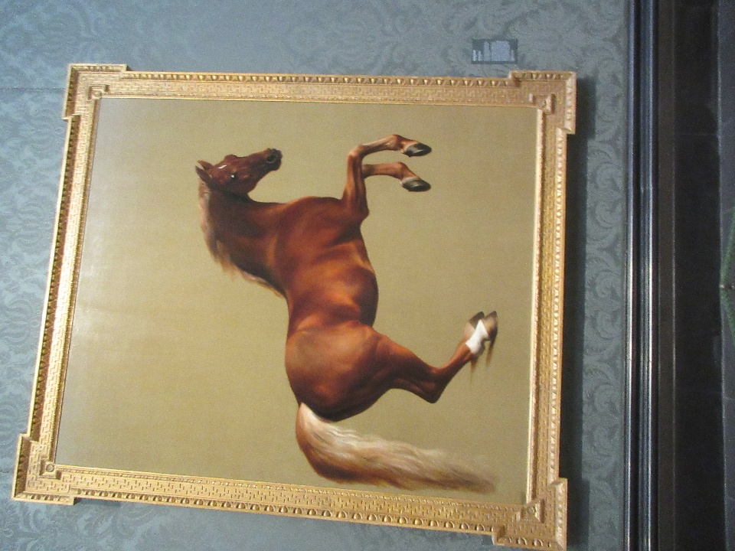
And of course, I always linger in front of the museum's pride and joy, and my personal favorite, Whistlejacket.

No room to display its full magnificence here, but the image is pretty much life size.

Around noon, we went to the "middle" of the museum's three eateries, the Ochre Brasserie, and had "afternoon tea" for lunch. Assam tea in heavy silver pots and this lovely three-tier stand bearing, from top to bottom, scones (plain and, on the far side, raisin) with strawberry jam, orange marmalade, and clotted cream; finger sandwiches (for each of us, one each of ham with tomato, mustard, and mayo; cucumber and butter; smoked salmon and dill; and egg salad with watercress); and a lemon meringue tart, a strawberry-cream-filled cake dome, and a tall cylinder of carrot cake. Yummy, all of it. The scones were way better than the little hockey pucks Viking serves at its afternoon teas.

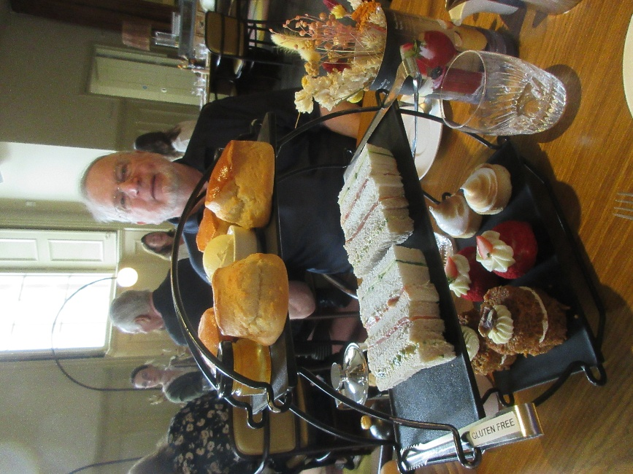
Then it was back to the hotel to rest up before strolling down to the famous Simpson's on the Strand (featured, e.g., in the Hitchcock film Sabotage and mentioned in many a Wodehouse novel and story) for dinner.

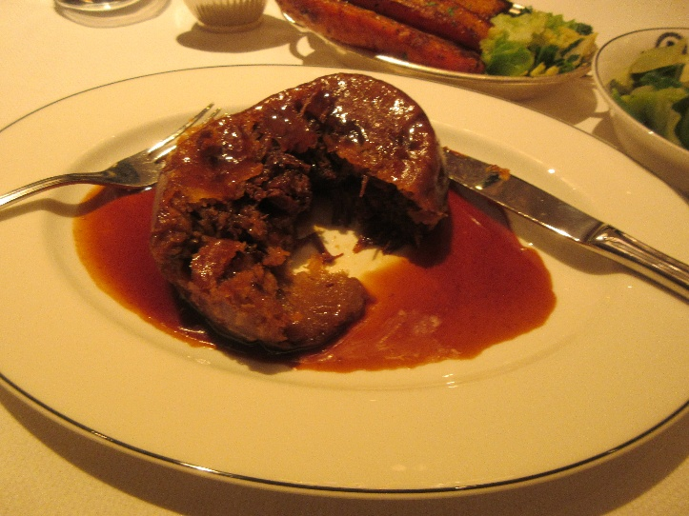
David started with an heirloom tomato salad, while I had flaked hot-smoked salmon trout with an endive salad and half a duck egg. Then I had the ox-cheek pudding and buttered cabbage. The juice was so rich it congealed on the plate as it cooled. (I was actually heartbroken to miss the following day's pudding of the day—steak and kidney. You can't get that anywhere any more.)

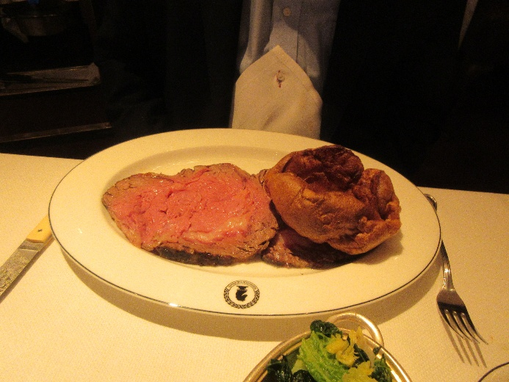
But David couldn't resist the roast beef trolley. They bring you a plate bearing a fluffy Yorkshire pudding, then the guy with a big carving knife rolls a huge silver-domed trolley to your table, opens it up, and proceeds to carve off two big slices (one is under the Yorkshire pudding) of beef of the degree of pinkness you specify. Then he presents you with a silver pitcher of gravy and, if you like, ladles a big dollop of horseradish sauce onto one edge. We've been to Simpson's before, and both had the beef—I can vouch that it's superb.

Above my plate you can see part of the "roasted root vegetables" that came with the beef—huge carrots and parsnips slow-roasted to buttery tenderness and caramelized edges. Boy, were they good!

For dessert, Eton mess of course.

Then across the street and down the block to the Adelphi Theatre for The Comedy About Spies, by the same people as The Play That Goes Wrong but, IMHO, way, way funnier. The opening sequence involving a whole crowd of secret agents who go by letters of the alphabet is an absolute classic, right up there with "Who's on First?"

Up to now, I've been writing pretty long-winded postcards filled with lots of photos, but that probably stops here. In the morning, we take the Eurostar through the Chunnel to Paris to join our Tauck tour, and once the tour guides open the information floodgates, I'll be scrambling just to download and transcribe my notes, let alone have time to write, so sorry if the postcards get shorter. I'll make it up later in the full-form travel diary . . .

